WENTWORTH LOCAL ENVIRONMENTAL PLAN 2011

PLANNING PROPOSAL REPORT

ENVIRONMENTAL PLANNING & ASSESSMENT ACT 1979 – S56 GATEWAY DETERMINATION

Sturt Highway, Gol Gol

August 2015

Table of Contents
- Introduction................................................................................................................................

  - The Planning Proposal...................................................................................................
  - Site and Locality............................................................................................................

- Objectives or Intended Outcome...............................................................................................

- Explanation of the Provisions.....................................................................................................

- Justification................................................................................................................................

  - Need for the Planning Proposal....................................................................................

  - Strategic Planning Framework......................................................................................
    - Wentworth Region Community Strategic Plan 2013-2023..............................
    - Wentworth Shire Council Economic Development Strategy 2011-2016..........
    - The Regional Development Australia Murray Regional Plan 2013-2016..........
    - Economic Development Strategy for Regional NSW January 2015.................

  - Environmental, Social & Economic Impact...................................................................
    - Environmental Impact.....................................................................................
    - Social Impact...................................................................................................
    - Economic Impact.............................................................................................

- Community Consultation..........................................................................................................

- Proposed Project Timeframe....................................................................................................

Attachments
- Jewel Markets Draft Concept Plan
- Aerial Photo
- Current Land Zone Map
- Additional Permitted Uses Map
- Floodplain Management Plan - Gol Gol to Abbotsford Bridge 1995, Kinhill Engineers Pty Ltd – Pages 7-10 and Figure 5.5
- Draft Floodplain Risk Management Study 2011, Worley Parsons Services Pty Ltd – Pages 23-27
- Consistency with SEPPs and S117 Directions
- Council Report and Resolution from Ordinary Council Meeting 18 March 2015

- INTRODUCTION
1.1 The Planning Proposal
This planning proposal is seeking an amendment to the Wentworth Local Environmental Plan 2011 to provide permissibility for the development of a retail business on the subject site.

The concept of The Jewel Markets will provide much needed retail services to the Buronga/Gol Gol community and an alternative retail opportunity for both local producers and consumers, whilst also acting as a social hub for Buronga, Gol Gol and the Sunraysia region.

Part of the market concept is to sell a broad variety of locally grown and made produce and products to the Sunraysia community and regional visitors, which will support and promote the region.

The development concept plan shows that the overall development site area is proposed to be 21,640 square metres. Within that area the total building area would encompass 6,500 square metres, the car parking area containing a total of 136 car spaces would be 4,500 square metres, a total retail area of 3,930 square metres and a small play area of 100 square metres.

The development concept plan also shows that internally there will be a mix of fixed shops, market stalls and a dry goods retail area. The definition of a dry goods retail outlet is a supermarket with provision for dry and/or manufactured goods only.

It is expected that the retail sales will include:
- Cafe and take away food and drinks premises
- Dry goods
- Fixed shops
- Market stalls.
Refer to Attachment 1 – The Jewel Markets draft concept plan.

Nearly every weekend a market is held in Mildura, Victoria. In particular, the Red Cliffs market held once a month is extremely popular with locals and tourists. The planning proposal aims to provide a similar atmosphere, all under the one roof, which would be open to the public anywhere between five and seven days per week (in accordance with Development consent).

1.2 Site and Locality
The planning proposal applies to Lot 2, DP 733735, Sturt Highway, Gol Gol.
The subject site, containing 8.11 hectares, is irregular in shape and has frontage to the Sturt Highway road reserve to the north and Carramar Drive to the south. The west portion of the site is vacant while the east side of the site contains aged vines along the Sturt Highway frontage.
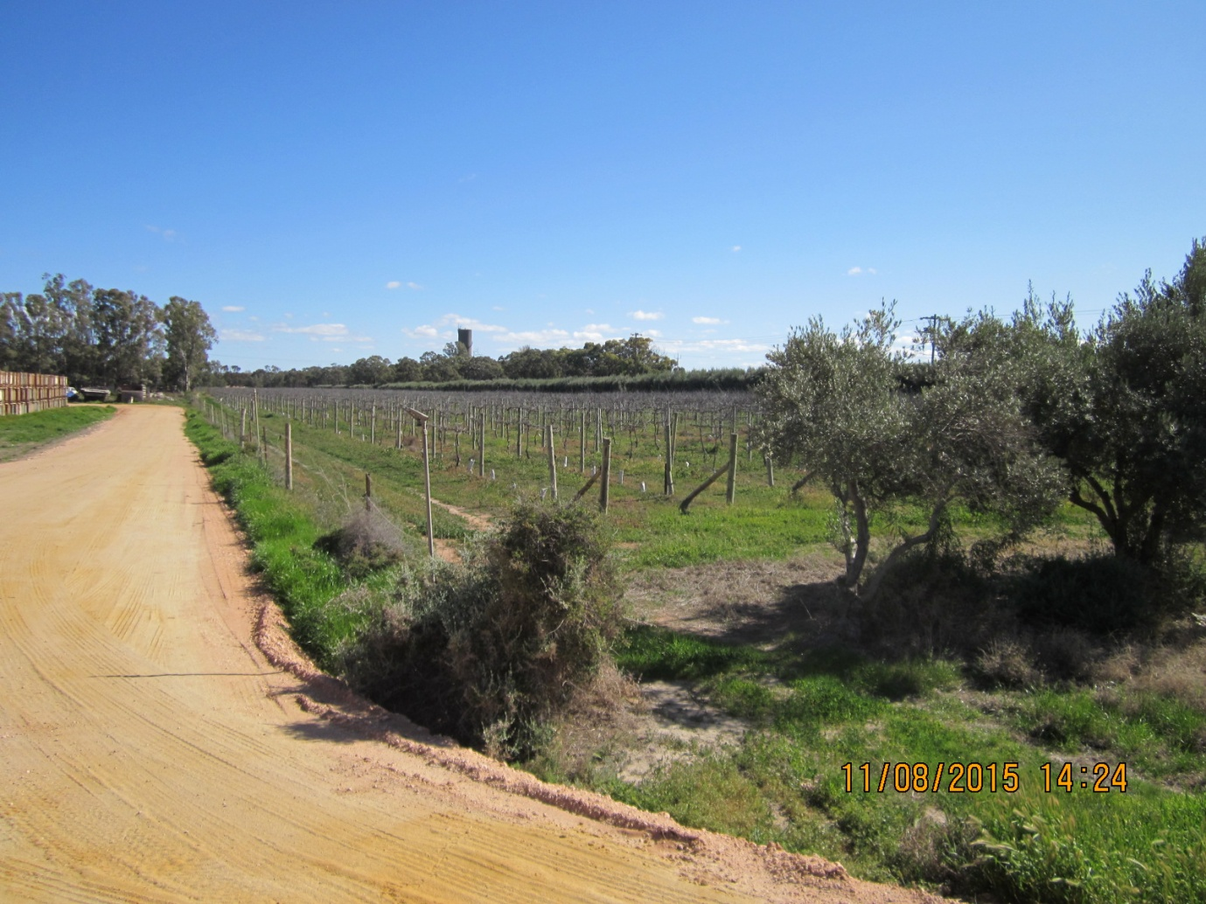
Photo 1 – Eastern boundary looking west

The subject site is slightly undulating from the Sturt Highway down to Carramar Drive, with the highest point of the site being along the Sturt Highway frontage.
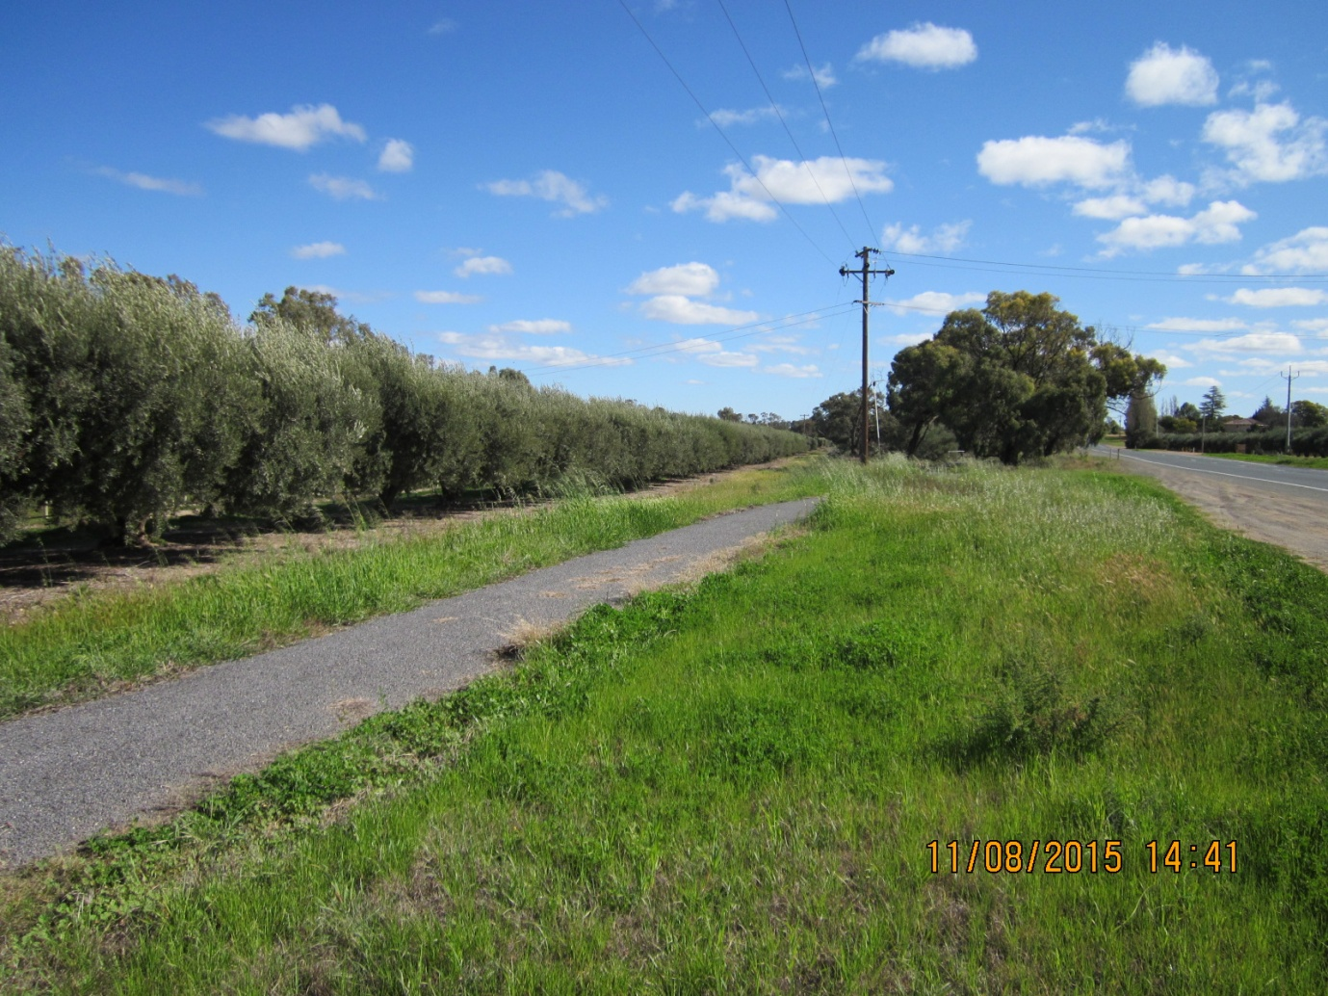
Photo 2 – Sturt Highway frontage looking west

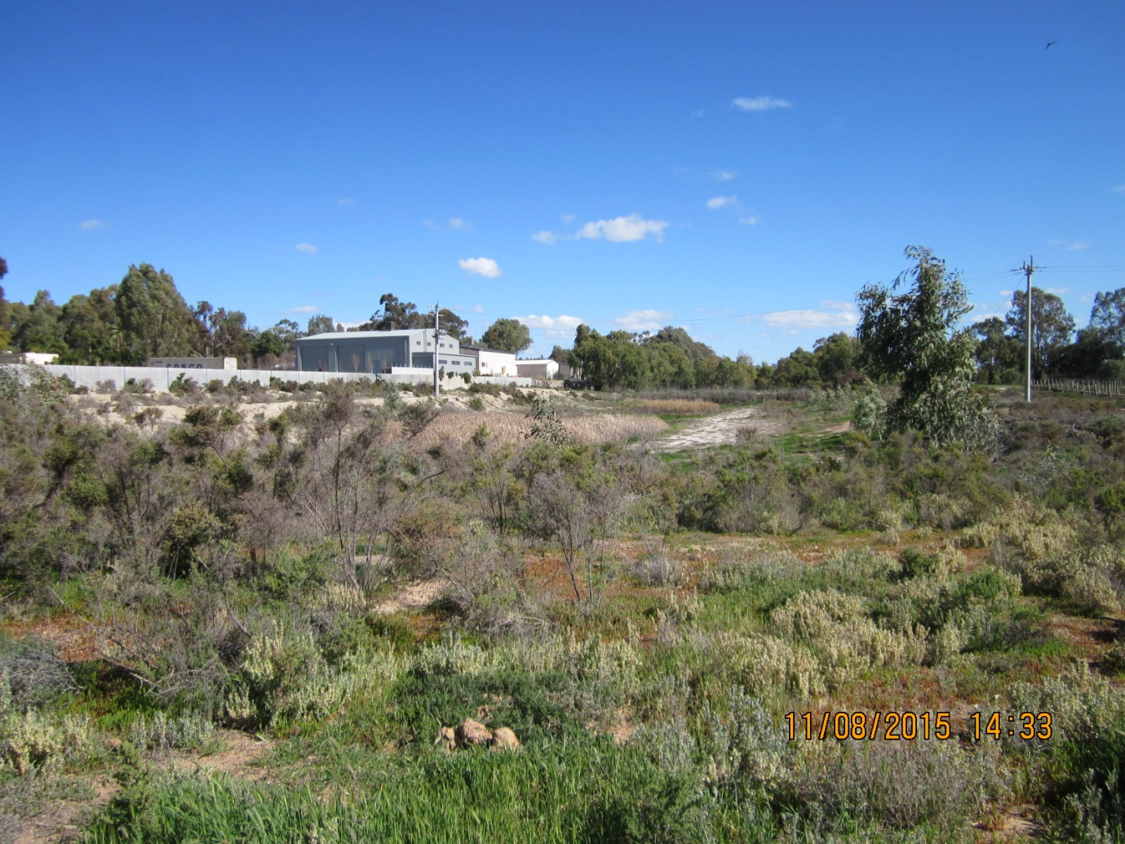
Photo 3 – Southern boundary looking west over existing stormwater basin
The large lots to the west of the site are vacant, the adjoining properties on the south western boundary consist of dwellings and associated buildings.
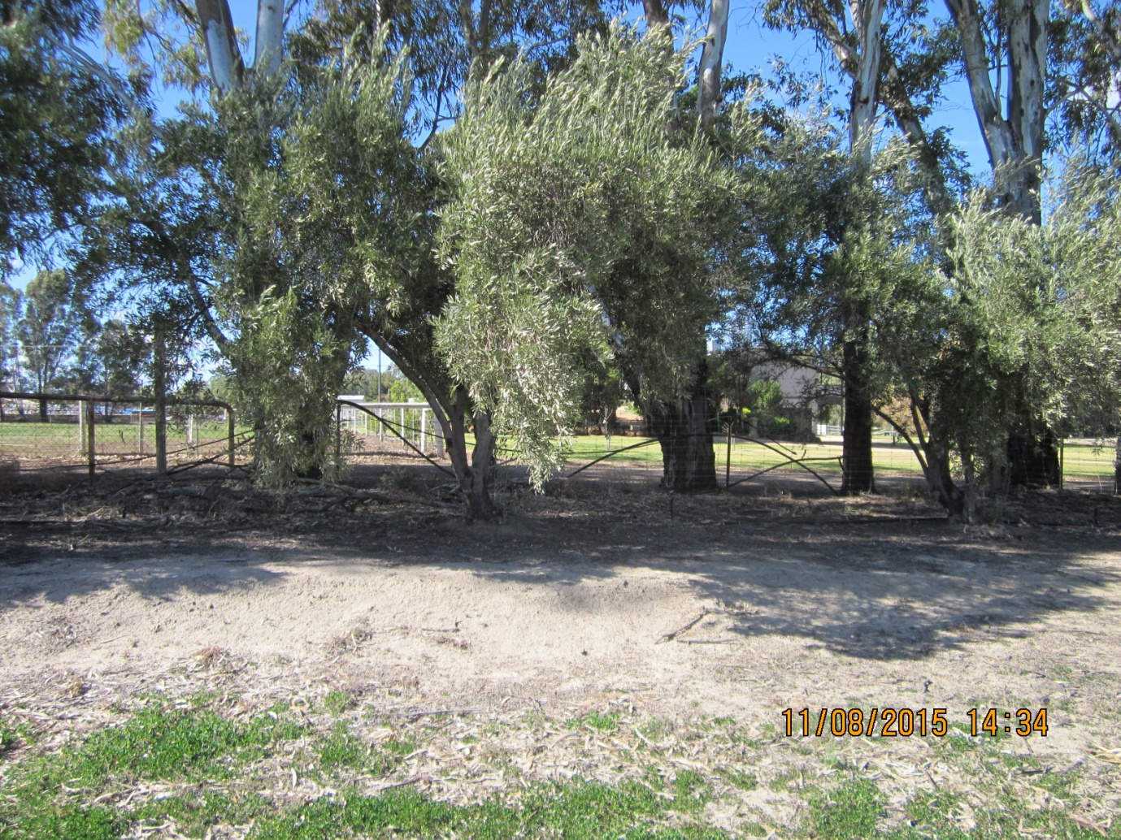
Photo 4 – Dwelling located south of the proposed development
The southern boundary abuts residential lots currently containing domestic sheds.
Refer to Attachment 2 – Aerial Photo.
Buronga/Gol Gol has a total population of 2,728 and currently is serviced by a very limited retail sector, which includes:
- Gol Gol Store and Bakery, 1.5 kilometres to the east – Photo 5
- Gol Gol Hotel, 1.5 kilomitres to the east – Photo 6
- Gol Gol Gift & Garden, 150 metres to the east – Photo 7
- Buronga Commercial development, including Pizza/Pasta Takeaway, Australia Post Agency, Accountant, Kitchen & Robes, 2.2 kilometres to the west – Photo 8
- Buronga Bakery, 2.2 kilometres to the west
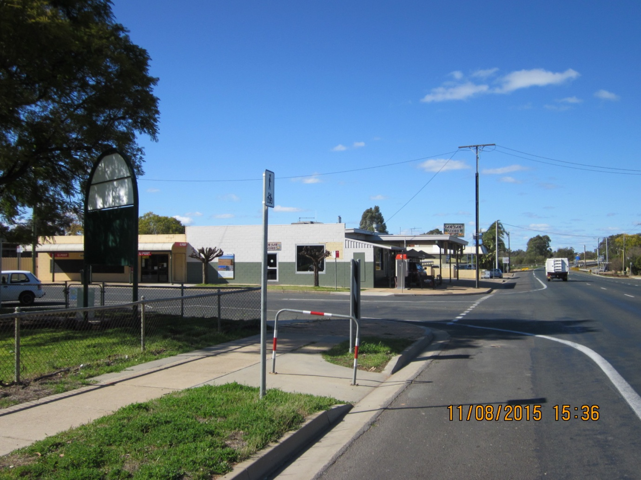
Photo 5 – Gol Gol Store and Bakery
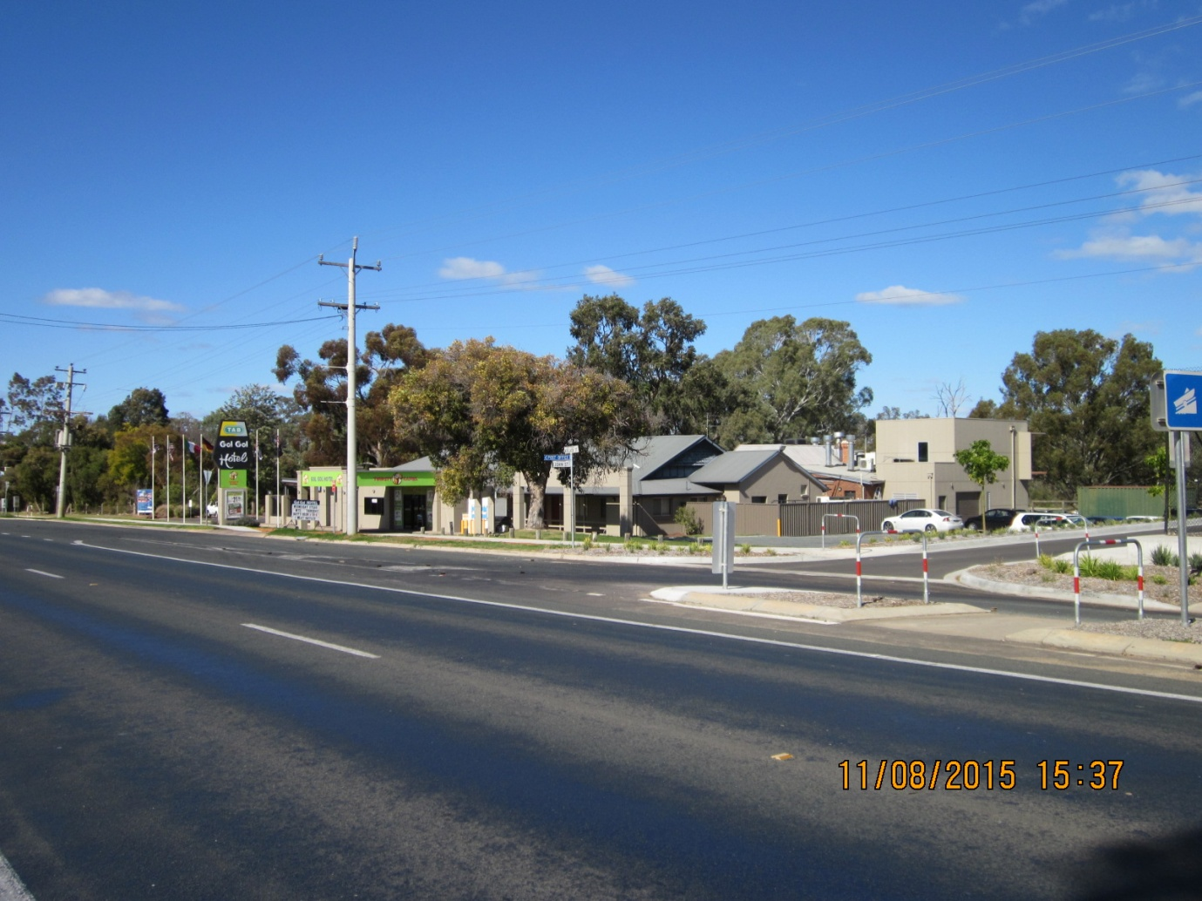
Photo 6 – Gol Gol Hotel
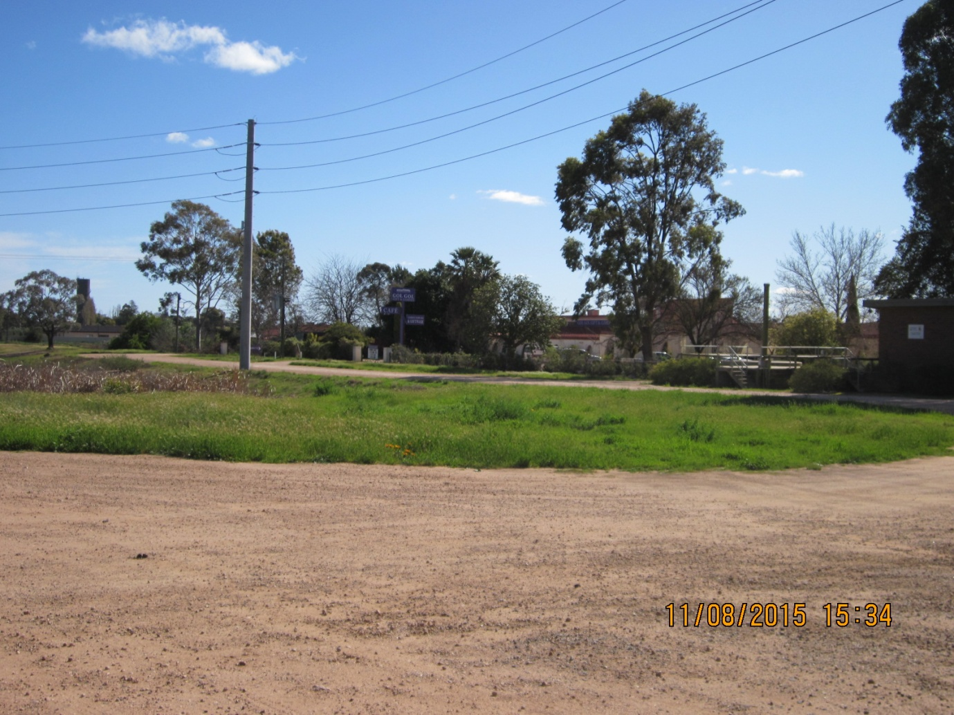
Photo 7 – Gol Gol Gift & Garden
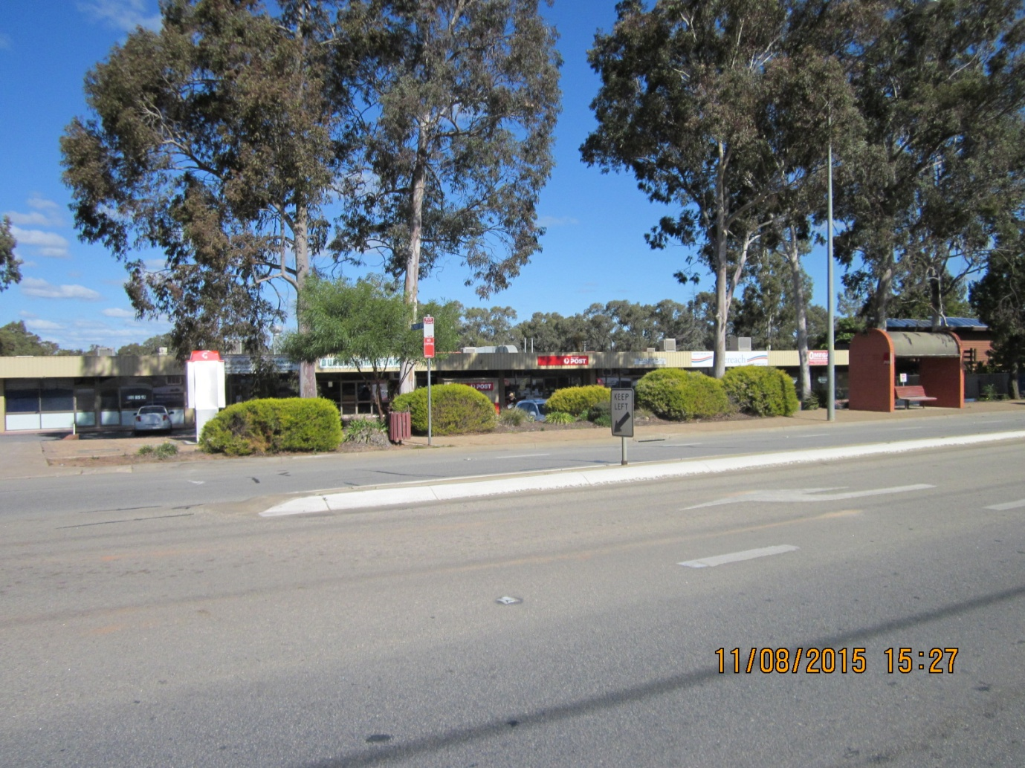
Photo 8 – Buronga Commercial Development
- OBJECTIVES OR INTENDED OUTCOMES
The aim of the planning proposal is to enable the development of a retail premises on Lot 2, DP 733735, Sturt Highway, Gol Gol while ensuring the site is not inappropriately or over developed by retaining the current zone applied to the land.
- EXPLANATION OF THE PROVISIONS
The proposed outcome will be achieved through amending the Wentworth LEP 2011 Schedule 1 Additional Permitted Uses and introducing an Additional Permitted Uses Map, as described below:
6 Use of certain land at Sturt Highway, Gol Gol
- This clause applies to Lot 2, DP 733735, Sturt Highway, Gol Gol and identified as “Area A” on the Additional Permitted Uses Map.
- Development for the purposes of Retail (Café/Take Away Food and Drink Premises, Shops, Market Stalls) is permitted with development consent.

- JUSTIFICATION

4.1 Need for the Planning Proposal

The current zone applied to the subject site is E3 Environmental Management zone. The purpose of the zone is to protect, manage and restore land that has ecological, scientific, cultural or aesthetic values and restrict development that would have an adverse impact on those values. In accordance with the provisions of the zone, the use and development of the site for retail purposes is prohibited.
Refer to Attachment 3 – Current Land Zoning Map.
In terms of obtaining permissibility for the development proposal, two alternative business zones were investigated.

B1 Neighbourhood Centre zone was considered as it provides for small-scale, convenience retail and business uses, medical facilities and shop top housing that would typically service the day to day needs of nearby residents. However, in consideration of the scale of the proposed development, the focus of attracting not only local shoppers but also retail tourism trade and the already, abundant supply of residential land in the area, the zone was considered inappropriate for the proposed use of the site.

B2 Local Centre zone was also considered for the site as it would allow for the use of the site for retail purposes. However, although the B2 Local Centre zone provides for larger scale commercial use, it creates a commercial precinct that also allows and accommodates for a range of uses including residential accommodation, educational facilities, function centres, offices and tourist and visitor accommodation. The additional permitted uses were considered superfluous to the proposal, the future use of the site and the surrounding land uses.

Although the development name reflects the use of the site as a market, the intent of the planning proposal is to allow for the use of the site for other retail purposes on more than an intermittent or occasional basis, as is the case with the standard definition of a market. Therefore, the sub categories of Café/Take Away Food and Drink Premises, Shops, Market Stalls are required to be included in Schedule 1 Additional Permitted Uses to ensure that the activities sought are permissible, while ensuring that not all uses under the retail definition can occur.

It is considered that amending the Wentworth LEP 2011 Schedule 1 Additional Permitted Uses and introducing an additional permitted uses map to allow for the use of the site for restricted retail purposes is the most efficient and effective means to enable the development of a retail premises on Lot 2, DP 733735, Sturt Highway, Gol Gol, while ensuring the site is not inappropriately or over developed by retaining the current zone applied to the land.
Refer to Attachment 4 – Additional Permitted Use Map.
  - Strategic Planning Framework

The planning proposal is consistent with the aims and objectives of the following strategic documents that are relevant to Wentworth Shire Council and its community:

4.2.1 Wentworth Region Community Strategic Plan 2013-2023

The Wentworth Region Community Strategic Plan highlights the community’s aspiration to be vibrant, growing and thriving by supporting a strong tourism industry, encouraging investment in business/industries, reducing red tape that restricts development and expanding employment opportunities. The plan also reveals the need to protect the natural environment.

The proposal is consistent with the Community Strategic Plan with its aim of increasing the supply of retail business, investment and employment opportunities in the Buronga/Gol Gol area. The inclusion of the use within Schedule 1 Additional Permitted Uses also restricts and protects the balance of the surrounding area from inappropriate overdevelopment and subsequently an increase in flood issues and risk.

4.2.2 Wentworth Shire Council Economic Development Strategy 2011-2016

One of the aims of the Economic Development Strategy is to promote the region and support the growth of tourism.

The planning proposal seeks to provide an opportunity for a local developer to construct a permanent building in Gol Gol that will provide a ‘market’ style environment in which local producers and their products can be show cased to the community and visiting tourists.

The strategy also supports the growth of small business, including the retail sector. The proposal will provide employment opportunities both in the retail and building trades, during the construction and operational phase.

The Buronga/Gol Gol area is heavily serviced by Mildura for the provision of goods and services. The planning proposal aims to expand the existing, very limited retail services provided to the local community and regional visitors of the growing Buronga/Gol Gol area.

It is considered that the planning proposal is consistent with the Economic Development Strategy.

4.2.3 The Regional Development Australia Murray Regional Plan 2013-2016

The RDA Murray Regional Plan states that ‘There are obvious sub-regional distinctions between various economic activities. The Western part of the region has a strong emphasis on fruit, nut, vegetable and wine production’ and ‘A significant proportion of visitor expenditure is likely to be spent on retail, accommodation and food service businesses, thus boosting these small scale businesses in the region.’

Located in the south west corner of New South Wales, one of the main economic drivers for the Shire is irrigated horticulture, in particular wine and table grapes, citrus fruit and vegetables and dry land agriculture.

The provision of a market style retail outlet for these producers will provide a local outlet to sell their products directly from farm to the consumer, ensures produce is locally grown and fresh and adds to the existing tourism attractions within the region.

Therefore, the proposal is consistent with the RDA Murray Regional Plan.

4.2.4 Economic Development Strategy for Regional NSW January 2015

The Strategy identifies five goals to enable economic growth:
· Promote key regional sectors and regional competitiveness
· Drive regional employment and regional business growth
· Invest in economic infrastructure and connectivity
· Maximise government efficiency and enhance regional governance
· Improve information sharing and build the evidence base

The proposed development is consistent with the strategy for Regional NSW as it promotes the horticultural, agricultural and artistic resources that are present in the region; provides employment opportunities and facilitates local business growth through the retail use of the development; while the ‘market’ element of the overall development concept will provide an additional tourism attraction for visitors.

4.2.5 Consistency with Section 117 Directions
Direction 2.1 - Environmental Protection Zones:

The objective of this direction is to:

* Protect and conserve environmentally sensitive areas.

There is no known or direct evidence, but it is assumed that the E3 Environmental Management zone was originally applied with the intention of protecting and managing the area due to the area being identified as a High Hazard Flood Storage area by the Floodplain Management Plan – Gol Gol to Abbotsford Bridge 1995 by Kinhill Engineers Pty Ltd .

Refer to Attachment 5 – Floodplain Management Plan - Gol Gol to Abbotsford Bridge 1995, Kinhill Engineers Pty Ltd – Pages 7-10 and Figure 5.5.

The High Hazard Flood Storage area in the then 1986 Floodplain Manual was described as floodwaters could cause structural damage to buildings and in extreme cases light framed houses could be washed away. Evacuation by heavy trucks would be difficult and other methods would be difficult and potentially dangerous. There could be danger to life and limb and social disruption and financial losses could be high.

A potential increase of flood levels as a consequence of the future development of the east Buronga area, between the Sturt Highway and Carramar Drive, west of the subject site was identified in the Draft Floodplain Risk Management Study 2011 by Worley Parsons Services Pty Ltd.

The study projected that the future development of this area would result in an increase of 50 mm or less to the 100 year RFL of the area to the east, including the subject site. This was considered insignificant and was supported by a recommendation to allow development in the area.

Refer to Attachment 6 – Draft Floodplain Risk Management Study 2011, Worley Parsons Services Pty Ltd – Pages 23-27.

Therefore, the planning proposal is consistent with the directions of the 2.1 Environment Protection Zones because:

- The Floodplain Management Plan – Gol Gol to Abbotsford Bridge 1995 by Kinhill Engineers Pty Ltd did not prohibit the development of the area,
- The Draft Floodplain Risk Management Study 2011 by Worley Parsons Services Pty Ltd did not prohibit the development of the area and considered that the slight increase in flood levels of the area, caused by the development of the land east of the subject site, was insignificant,
- It continues to protect and conserve the area due to the planning proposal seeking to allow a single use/development, and
- It does not seek to reduce the environmental standards that currently apply to the land.

Direction 3.4 Integrating Land Use and Transport

Refer to Attachment 7 – Consistency with SEPPs and S117 Directions.
Direction 4.3 - Flood Prone Land:

The Wentworth LEP 2011 Flood Planning Area Map Sheet CL1_004F is applied to the site and its surrounds. The application of the Flood Planning Area mapping does not prohibit development but ensures that all development applications respond to the applicable provisions of the Wentworth LEP 2011 and Wentworth Development Control Plan.

Refer to Attachment 8 – Wentworth LEP 2011 Flood Planning Area Map Sheet CL1_004.

The Wentworth Development Control Plan requires the construction of all buildings to have a floor level at a minimum of 750 mm above the 100 year recurrence flood level. A recommendation of the Draft Floodplain Risk Management Study 2011 by Worley Parsons Services Pty Ltd requires commercial development to have at least 25% of the floor level at an elevation equal to the 100 year recurrence flood level plus a minimum of 750 mm. While the remaining 75% of the floor level at a level equivalent to the 100 year recurrence flood level.

The objectives of this direction are to:
* To ensure that development of flood prone land is consistent with New South Wales Government Flood Prone Land Policy and principles of Floodplain Development Manual 2005; and
* To ensure that the LEP provisions adequately address the flood hazard and considerations of flood impacts on and off the site.
The current flood control provisions within the Wentworth LEP 2011 have been formulated from the results of the Draft Floodplain Risk Management Study 2011 by Worley Parsons Services Pty Ltd. This study was developed consistently in line with the Floodplain Development Manual 2005. Accordingly, Council has resolved to complete the project with the re-engagement of Worley Parsons Services Pty Ltd to review the current data and develop a Floodplain Risk Management Plan.
It is considered that the planning proposal:
- Will not provide for the permissibility of development in a floodway area
The Floodplain Development Manual 2005 Floodway Area definition: those areas of the floodplain where a significant discharge of water occurs during floods. They are often aligned with naturally defined channels. Floodways are areas that, even if only partially blocked, would cause a significant redistribution of flood flow, or a significant increase in flood levels.

There is no reference in either of the flood reports that indicates that this area is a floodway area. ie natural water ways or channels.

Floodplain Development Manual 2005 Flood Planning Area definition: the area of land below the FPL and thus subject to flood related development controls. The concept of flood planning area supersedes the "flood liable land" concept in the 1986 manual.

The site is subject to the Flood Planning Area maps in the WLEP 2011.

Therefore, the planning proposal does not seek to provide permissibility of development in a 'floodway area'. However, it does seek to provide permissibility of development in a 'flood planning area'.
- Will not significantly impact any surrounding properties
In the event of a flood at a height equal to the floor level of the building, the design and layout of the proposed development will allow for the movement of any flood water to flow through the building. The position of the building on the site, being orientated east/west, will not significantly impede the flow of flood water through the area and therefore, will not cause an increase of a flood impact on surrounding properties.
- Aims to provide for the permissibility of one additional use on the land

Consideration of the overdevelopment of the site has been undertaken, therefore, only one additional permitted use has been included as part of the planning proposal.

- Will not require an increase in government funding for additional infrastructure to support the proposal

The proposal will require works to be undertaken to provide access to Sturt Highway and a service road to be constructed. The cost of work and provision of infrastructure will be borne by the developer.

- Will not provide the ability to proceed without development consent.

Development consent will be required prior to the commencement of any works or construction.

It is considered that the planning proposal is consistent with the objectives of the Section 117 Direction 4.3 Flood Prone Land.
6.3 Site Specific Provisions
Refer to Attachment 7 – Consistency with SEPPS and S117 Directions.
    - Consistency with State Environmental Planning Policy
SEPP 55 – Remediation of Land
Refer to Attachment 7 – Consistency with SEPPs and S117 Directions.
  - Environmental, Social & Economic Impact
4.3.1 Environmental Impact
The site does not contain any critical habitat or native vegetation that would be under threat with the development of the subject site.

The planning proposal is not a consequence of a related strategy or study, however, the subject site and its immediate surrounds are referred to in the Floodplain Management Plan - Gol Gol to Abbotsford Bridge 1995 by Kinhill Engineers Pty Ltd and the Draft Floodplain Risk Management Study 2011 by Worley Parsons Services Pty Ltd. Refer to 4.2.5. Consistency with S117 Directions and 4.3.1 Environmental Impact for further details.

A response to the potential on and off site flood impacts is provided in Section 4.2.5 Consistency with Section 117 Directions.
4.3.2 Social Impact
Nearly every weekend an open air market is held in Mildura, Victoria. In particular, the Red Cliffs market held once a month is extremely popular with both locals and tourists. The planning proposal aims to provide a similar atmosphere, all under the one roof, which would be open to the public anywhere between five to seven days per week (in accordance with an approved Development Application).

The concept of The Jewel Markets is to provide an alternative retail opportunity for consumers, whilst also acting as a social hub for Buronga, Gol Gol and the Sunraysia region. The market will provide a permanent location for people to meet, socialise and be entertained by local talent, ie artists, musicians and will contain a broad variety of local produce and products for the community and regional visitors. This type of activity will support and promote the horticultural, agricultural and artistic capacity of the local community.

4.3.3 Economic Impact
The Jewel Markets will provide retail services to the Buronga/Gol Gol and regional visitor community and aims to provide an alternative retail opportunity for local producers to showcase and sell their products.
The producers will have the opportunity to competitively sell directly to the consumer, thereby reducing the ‘middle man’ costs and transportation expenses to large regional cities or centres. It will also provide for a central shopping centre for the local community and visitors with produce being grown and sold in the region.
The proposal will provide for employment during the construction phase of the development and ongoing employment opportunities during the operational phase.
- COMMUNITY CONSULTATION
Pursuant to Section 56(2)(c) and 57 of the Environmental Planning and Assessment Act 1979 exhibition of the planning proposal will be conducted over a 28 day period as follows:
- Public notice in the Mildura Weekly newspaper, and
- Advertised on the Wentworth Shire Council website, and
- Written public notice to the following State Agencies –
  - Murray Catchment Management Authority
  - NSW Office of Water
  - Essential Energy
  - Office of Environment & Heritage
  - Roads and Maritime Services
The following information will be made available for inspection:
- The Gateway Determination
- The planning proposal documentation
- Site locality and aerial maps
Community consultation will be complete when Wentworth Shire Council has appropriately and effectively considered all submissions received relative to the planning proposal.
- PROPOSED PROJECT TIMELINE
This project timeline will provide a mechanism to monitor the progress of the planning proposal:
Gateway Determination | September
Community Consultation, incl State Agencies | October
Consideration of submissions | November
Consideration of a proposal post exhibition | December
RPA Adoption to make Plan | January
Submission date to DP&E & PCL to finalise LEP | February
Forward to Department for notification | March

